**[REV.00]**

**KernelBand**

**Calculation Method**

**Contents**

1 Purpose 3

2 Improvement of KernelBand Calculation 3

2.1 Relation between Weight and Distance 3

2.2 Relation between Weight and KernelBand 5

# Purpose

To figure out how to calculate optimal kernelband in AAKR algorithm.

# Improvement of KernelBand Calculation

## Relation between Weight and Distance

In the AAKR algorithm, the weight is calculated as follows.

$$w=\frac{1}{\sqrt{2πh^{2}}}e^{-\frac{d^{2}}{h^{2}}}$$

Let’s look at the w-d graph below.

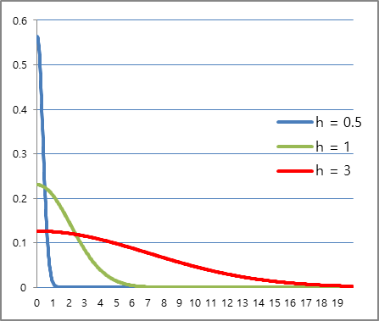

**d**

**w**

As you can see the right graph, If h is constant, you can see a graph in which w decreases as d increases.

Therefore, it can be seen that w is inversely proportional to d.

$$w∝\frac{1}{d}$$

Then let’s see the distance (d)

Let assuming Act Value (Tag 1, Tag 2, Tag 3, … Tag m) is the xm, The Sample of each tags is Xmn , The distance between the ActValue and Sample[n] is dn,

dn is as follow.

$$d_{n}=\sqrt{\sum{{{{CF}_{m}}^{2}(X_{mn}-x_{m})}^{2}}}$$

It can be seen that the distance is calculated only from the actual value and the sample data. In other words, the distance between each sample and actual value is constant regardless of the Kernel Band changing.

Therefore, the sample having a minimum distance between the actual value and the sample will have the maximum weight.

The following is the result of calculating the distance and weight using the above-mentioned sample. (Kernel Band is set to 10)

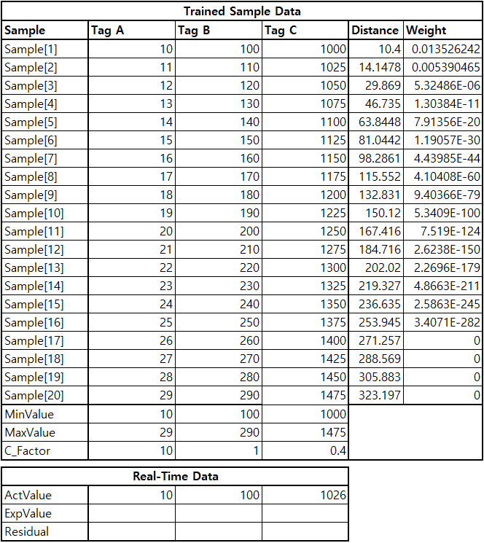

**KernelBand : 10**

Figure 5

As described above, the Sample [1] with the smallest distance has the highest weight value.

## Relation between Weight and KernelBand

I first explained that to ensure that the weight has a maximum value, the distance should have a minimum value. So how do we find the Kernel Band?

$$w=\frac{1}{\sqrt{2πh^{2}}}e^{-\frac{d^{2}}{h^{2}}}$$

Let’s see the below w-h graph (it used the sample from the above example)

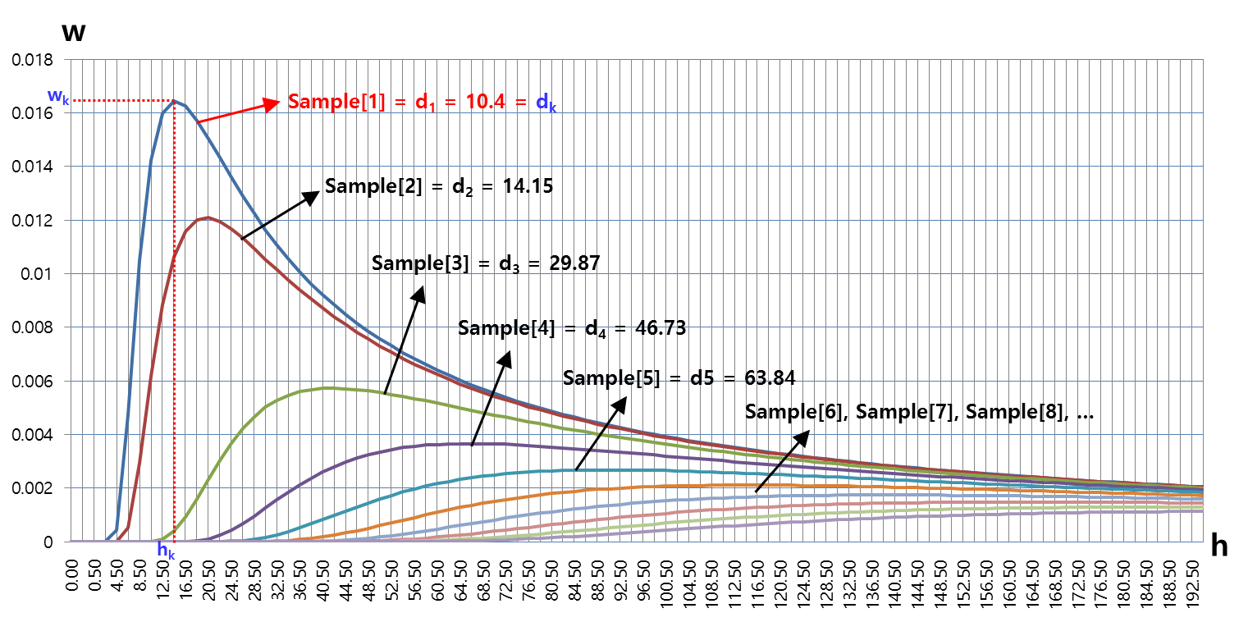

Figure 6

If we want to find the maximum weight value (wk) and Kernel Band (hk), we can see that point in the graph above. Also, as we already know, we can see that the weight is the highest at d1 with the smallest distance.

Assuming d and h that w having the maximum values are dk, hk The following equation holds.

$$w_{k}=\frac{1}{\sqrt{2π{h_{k}}^{2}}}e^{-\frac{{d_{k}}^{2}}{{h_{k}}^{2}}}$$

Since dk is calculated using the difference between the actual value and sample data, it can be considered as a constant. And it can be expressed by the equation for h as follows.

$$f\left(h\right)=\frac{1}{\sqrt{2πh^{2}}}e^{-\frac{{d_{k}}^{2}}{h^{2}}}$$

In the Figure 6, hk is the value of h satisfying $\frac{d}{dh}f\left(h\right)=0$ because wk is the maximum value

$$f^{'}\left(h\right)=\frac{d}{dh}\left\{\frac{1}{\sqrt{2πh^{2}}}e^{-\frac{{d_{k}}^{2}}{h^{2}}}\right\}=0$$

$$=\frac{1}{\sqrt{2π}}\frac{d}{dh}\left(\frac{e^{-\frac{{d_{k}}^{2}}{h^{2}}}}{h}\right)$$

$$=\frac{\frac{d}{dh}\left(\frac{1}{h}\right)e^{\frac{{d_{k}}^{2}}{h^{2}}}+\left(\frac{1}{h}\right)\frac{d}{dh}\left(e^{-\frac{{d_{k}}^{2}}{h^{2}}}\right)}{\sqrt{2π}}=\frac{-\frac{1}{h^{2}} e^{-\frac{{d_{k}}^{2}}{h^{2}}} - \frac{1}{h} \frac{d}{dh}\left(\frac{{d_{k}}^{2}}{h^{2}}\right) e^{-\frac{{d_{k}}^{2}}{h^{2}}}}{\sqrt{2π}}$$

$=\frac{-\frac{1}{h^{2}}e^{-\frac{{d_{k}}^{2}}{h^{2}}} - \frac{{d_{k}}^{2}}{h} \left(-\frac{2}{h^{3}}\right) e^{-\frac{{d_{k}}^{2}}{h^{2}}}}{\sqrt{2π}}=\frac{-\frac{1}{h^{2}}e^{-\frac{{d_{k}}^{2}}{h^{2}}}- \left(-\frac{2{d_{k}}^{2}}{h^{4}}\right) e^{-\frac{{d_{k}}^{2}}{h^{2}}}}{\sqrt{2π}}$

$$= \frac{-h^{2}e^{-\frac{{d_{k}}^{2}}{h^{2}}}+2{d_{k}}^{2} e^{-\frac{{d_{k}}^{2}}{h^{2}}}}{\sqrt{2π}h^{4}}= \frac{ e^{-\frac{{d_{k}}^{2}}{h^{2}}}\left(2{d_{k}}^{2}-h^{2}\right)}{\sqrt{2π}h^{4}}$$

$⇨In order for f^{'}\left(h\right)=0, 2{d_{k}}^{2}-h^{2}=0$,

$$h_{k}=±d_{k}\sqrt{2}$$

$∴h_{k}=d_{k}\sqrt{2} \left(because h>0\right),$ wk has the maximum value.

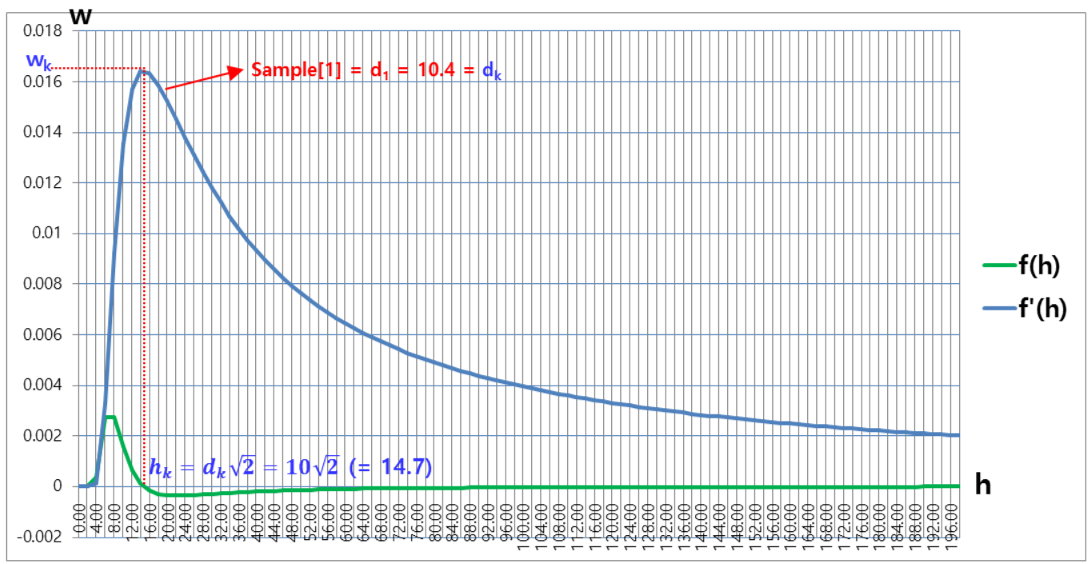

Figure 7

Therefore, in the above figure, KernelBand(hk) which has the highest weight is 10.4√2(=14.7).

Note : You can also consider this point which having a maximum value of f’(h) = $d_{k}\sqrt{\frac{5-\sqrt{17}}{2}}$

$$(=6.886)$$